Document History
Basic information
Document owner |  | James Buller, Senior Windows Engineer
Approver |  | Dan Morgan, Windows Team Lead
Administrator |  | James Buller, Senior Windows Engineer
Status |  | Live
Archive until |  | N/A
Review cycle |  | Annually
Document location |  | ISSC1 Infrastructure Team SharePoint
Document classification: |  | Internal
Special instructions |  | N/A
Responsible function |  | ISSC1 Infrastructure Team
Addressee(s) within Arvato |  | ISSC1 Infrastructure Team
Training approach |  | Team and 1:1
Version information
Version: | Date: | Author: | Comments:
0.1 | 01/01/2023 | James Buller | Draft
1.0 | 01/01/2023 | James Buller | Initial / Distrubuted / Trained
1.1 | 09/08/2023 | James Buller | Updates (Changes in bold / highlighted)
2.0 | 10/08/2023 | James Buller | Approved by Dan Morgan (Windows Team Lead)
2.1 | 15/09/2023 | James Buller | Updates (Changes in bold / highlighted) / Headings updated in audit spreadsheet and link added in NOTES – Awaiting Approval.
2.2 | 15/09/2023 | James Buller | Approved by Dan Morgan (Windows Team Lead)
2.3 | 12/12/2023 | James Buller | Updates (Changes in bold / highlighted) / Headings updated in audit spreadsheet and link added in NOTES – Awaiting Approval.
2.4 | 26/11/2024 | Aamir Miah | Updated Swansea DC’s and added PDQ Guidance to the following sections:  Storage Capacity  Domain Controllers

Contents
Scope: 3
Prerequisites: 3
Information: 3
ICT Infrastructure Checks. 3
Procedure. 3
Prerequisites. 3
Process. 4
Checks. 5
Ticket Stack Check 5
Domain Controllers 6
Storage Capacity 8
Interflex (Door system checks). 9
Clearswift Proxies 10
Backup Progress Status 10
Server room checks 10
Completion. 10
Troubleshooting. 11
Notes. 11

Scope:
This document will assist team members carrying out the ICT Infrastructure morning checks, detailing the required steps needed for a successful audit. If in doubt, then please seek advice before proceeding.
  - Activities are to be carried out by ICT infrastructure team members only.

Prerequisites:
Below is a list of pre-requisite access requirements to successfully perform checking activities:
- Access to the ICT infrastructure Teams group.
- Valid credentials to the following systems:
  - Domain Controllers (SSC / SSAP / SSANP / SSAHS).
  - Clearswift Proxies (AWS CS1 / AWS CS2).
  - Microsoft 365 Global Administrator / Security Operator.
  - SAP CRM.
  - Civica CRM.
  - Associated ICT infrastructure Team Mailboxes:
    - Windows Support
    - FOSS Infrastructure
    - AWS Alerts
  - VMware Hosts.
  - Interflex VM (Door Controls).
  - Team Crib sheet.
  - Team Area Directory (J:\ICT\56. Infrastructure\).
  - Server / Comms Room Access.

Information:

ICT Infrastructure Checks.
Arvato’s infrastructure is made of multiple components, physical / environmental and informational, working together to provide a reliable service to our end users and clients. Carrying out these checks allow us to make sure that there are no issues for the set period and if any are identified, then can be resolved quickly and efficiently. These allow us to maintain our high standards and business accreditations.

Procedure.

Prerequisites.
- All the access accounts listed above.
- ICT infrastructure Teams group.
- Access to the ‘Team Checks’ sub channel in the ICT infrastructure Teams group.

Process.
All checks are carried out using a custom created ‘Form’ in MS Teams.
Instructions for each check are located within the relevant area so please read for full guidance, if changes are made to the instructions on these tasks, then this will be communicated to the team via email / team’s message.
- Open the Teams application and click on the following:
  - ‘Teams’ icon.
  - ICT Infrastructure.
    - Team Checks.
  - Top navigation bar – ‘Morning Checks’
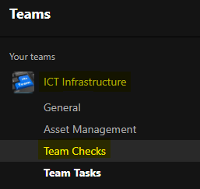
- Click on the ‘Start Now’ button as shown below.
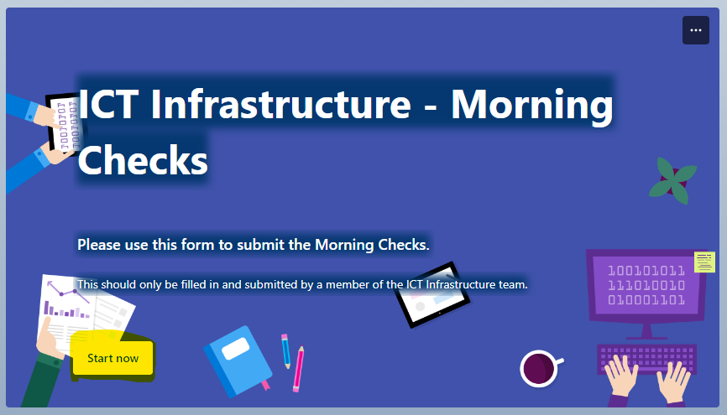
- Carry out the following:
  - Review instructions.
  - Provide the relevant information.
  - Mark as:
    - OK – No Issues.
    - Issue – Include information in the mandatory note.
    - N/A – Task not carried out - Include a reason in the mandatory note.
  - Screenshot if needed.
  - Notes – Always include notes were possible for each section for management visibility and audit purposes.
- Once all sections are marked appropriately then ‘Submit’ can be pressed.

- This will now submit the form for review by the team management and signed off.
- You will be notified in ‘Teams’ once the check has been approved.

Checks.
Below are the checks that need to be completed for the morning checks.

Ticket Stack Check
- Ticket count in SAP Support Portal
  - Instructions - go to the following URL and provide a count of how many tickets are applicable to our team - https://sapportal.sharedservicesarvato.co.uk/irj/portal
  - Click on ‘Interaction Centre’.
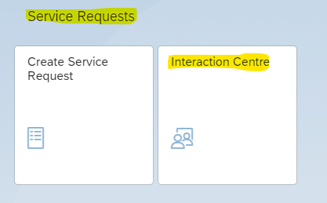
  - Click on ‘Inbox’ to bring up the ticket list in the main panel.
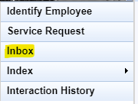
- Ticket count in Agresso
  - Instructions - go to the following URL and provide a count of how many tickets are applicable to our team - https://www.sharedservicesarvato.co.uk/
  - Click on and action the following:
    - ‘Desktop Applications’.
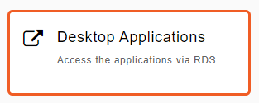
    - Log into the RDS system with your credentials.
    - Click on ‘Civica CRM’ and follow and accept the prompts.

    - Log into the application with your credentials.
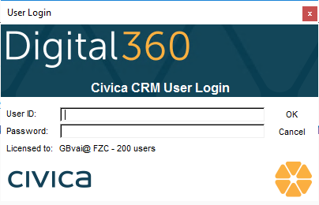
    - Select ‘Group Trays’ and you will be shown how many tickets there are.
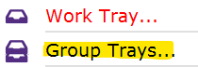
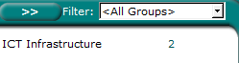
- Ticket status in the Windows Support Mailbox
  - Instructions - Access the Windows Support Mailbox via Outlook and note the number of active emails.
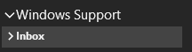
- Ticket status in the FOSS Infrastructure Mailbox
  - Instructions - Access the FOSS Infrastructure Mailbox via Outlook and note the number of active emails.


Domain Controllers
- Using remote desktop connection, you will need to log in to each of the servers listed below and perform the actions noting any critical errors or events of interest.
In most cases a jump box will be required to get connected to the relevant instances.
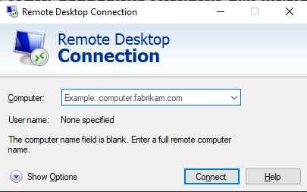
SSC | Production | Non-Production | Hosted Services
ARVSSADC2203 | AWSARVM100 | AWSARVM200 | AWSARVM300
ARVSSADC2204 | AWSARVM101 | AWSARVM201 | AWSARVM301
AWSARVM700
AWSARVM701

- When connected launch ‘Event Viewer’
  - Start >> Administrative Tools >> Event Viewer
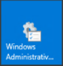 >> 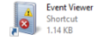
- Make a note of errors and events of interest in the last hour and 24 hours.
Double click on them for more information.
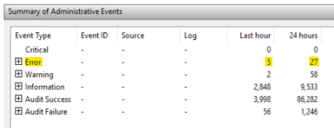
- Carry out the above on all instances listed above.
Alternatively, Errors can be viewed for all Domain controllers on the PDQ Console in AWSARVM312 or via the email report in Windows Support Mailbox >> PDQ Notifications

PDQ is scheduled to collect Domain Controllers errors present in the last 24 hours at 7:30AM

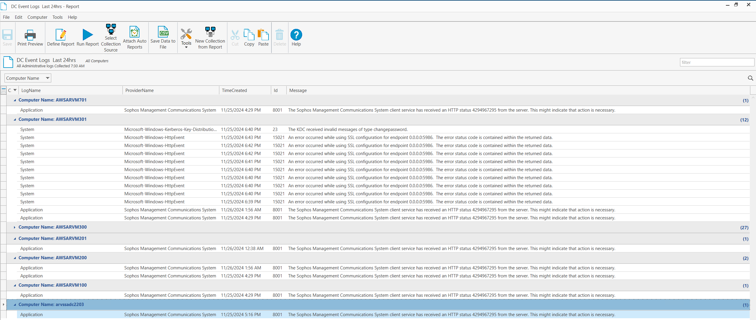

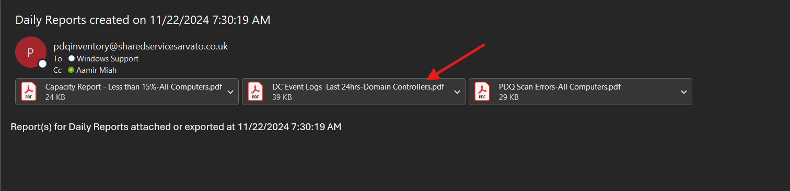

Storage Capacity
- When logging on to the following servers then please note if the hard disk capacity is showing in RED and report.
SSC
ARVSSADC2203
ARVSSADC2204

Alternatively Hard Disk Capacity report can be reviewed from the PDQ - Daily Report.

PDQ is scheduled to scan all servers daily and report on any instance with a Disk Capacity below 15%

Report is emailed to the Windows Support Mailbox >> PDQ Notifications or can be viewed directly in the PDQ Inventory Console on AWSARVM312.

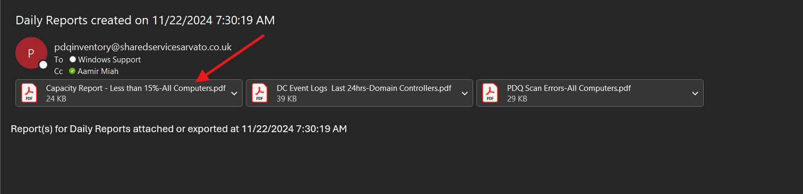

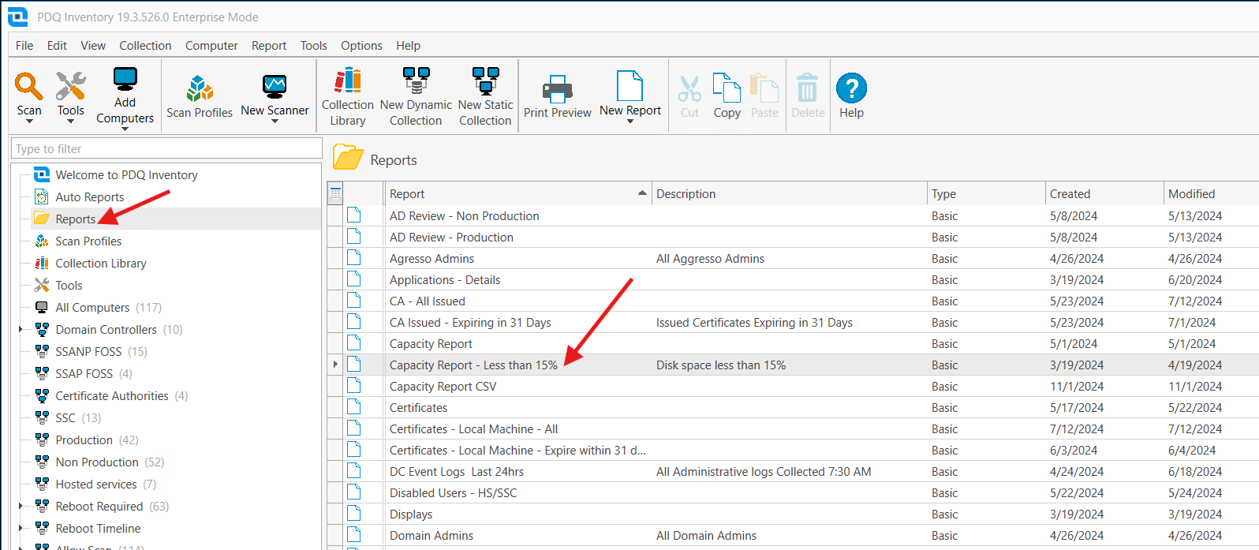

- If no issues, then please report ‘N/A’.

Interflex (Door system checks).
- Open and log into VMware - VMware Console
- Launch a VM called ‘ARVSSAINT01’
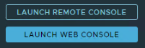
- Launch a web browser and go to – http://localhost/BAWebClient/site/bioclient/grid
Use the credentials from the team crib sheet to gain access.
- You need to check and confirm that all biometric door readers are online and ok for all and note any issues.
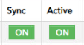
- There is also a desktop application to check on the VM – Launch from the desktop a program called ‘6020 System’.
Use the credentials from the team crib sheet to gain access.
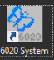
- Once in the system, using the navigation bar at the top click on Terminals > Online..
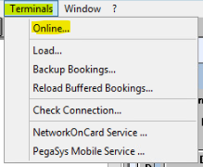
- Please note any issues if the below screen is not showing.
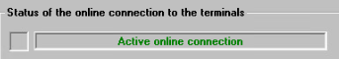

Clearswift Proxies
- Log on to each Clearswift Web Proxy with your credentials to check alarms below.
  - AWS CS 1 - Console
  - AWS CS 2 - Console
- The home screen will appear and in the upper right-hand corner will show alarm statuses.
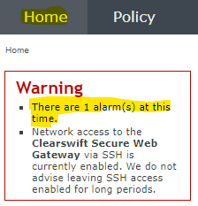
- Note any alarms and events of interest.

Backup Progress Status
- Access the AWS Alerts Mailbox via Outlook and locate an email with the subject of ‘backup-report’.
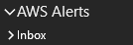
- Review the contents of this email report, all instance IDs should be ‘COMPLETED’.
- Please note any exceptions, events of interest or simply that all have completed.

Server room checks
- You will need to check the following in the upper and lower server rooms.
  - Check door is locking.
  - Check cabinets for power.
  - Check roof tiles for water leaks.
  - Check key safe is locked.
  - Check light is off on the way out.
  - Who carried out this Check (if not you).
- Please note any exceptions, events of interest or simply that all have completed.

Completion.
Once all the tasks and relevant checks have been completed an email with key information will be communicated to other team members / management automatically.
All information provided in the form will be communicated to the team and team management.
The checks will also be briefly discussed in the morning team meeting, please advise if there any issues not covered.

Troubleshooting.
Any issues with the ‘Form’ or ‘Teams’ not submitting or showing checks then please consult with team management or a ‘teams’ subject matter expert.

Notes.
If any further assistance is needed, then please contact your line manager to seek further advice and guidance on any issues at all.
Link to audit spreadsheet - Morning Check Audit Record

